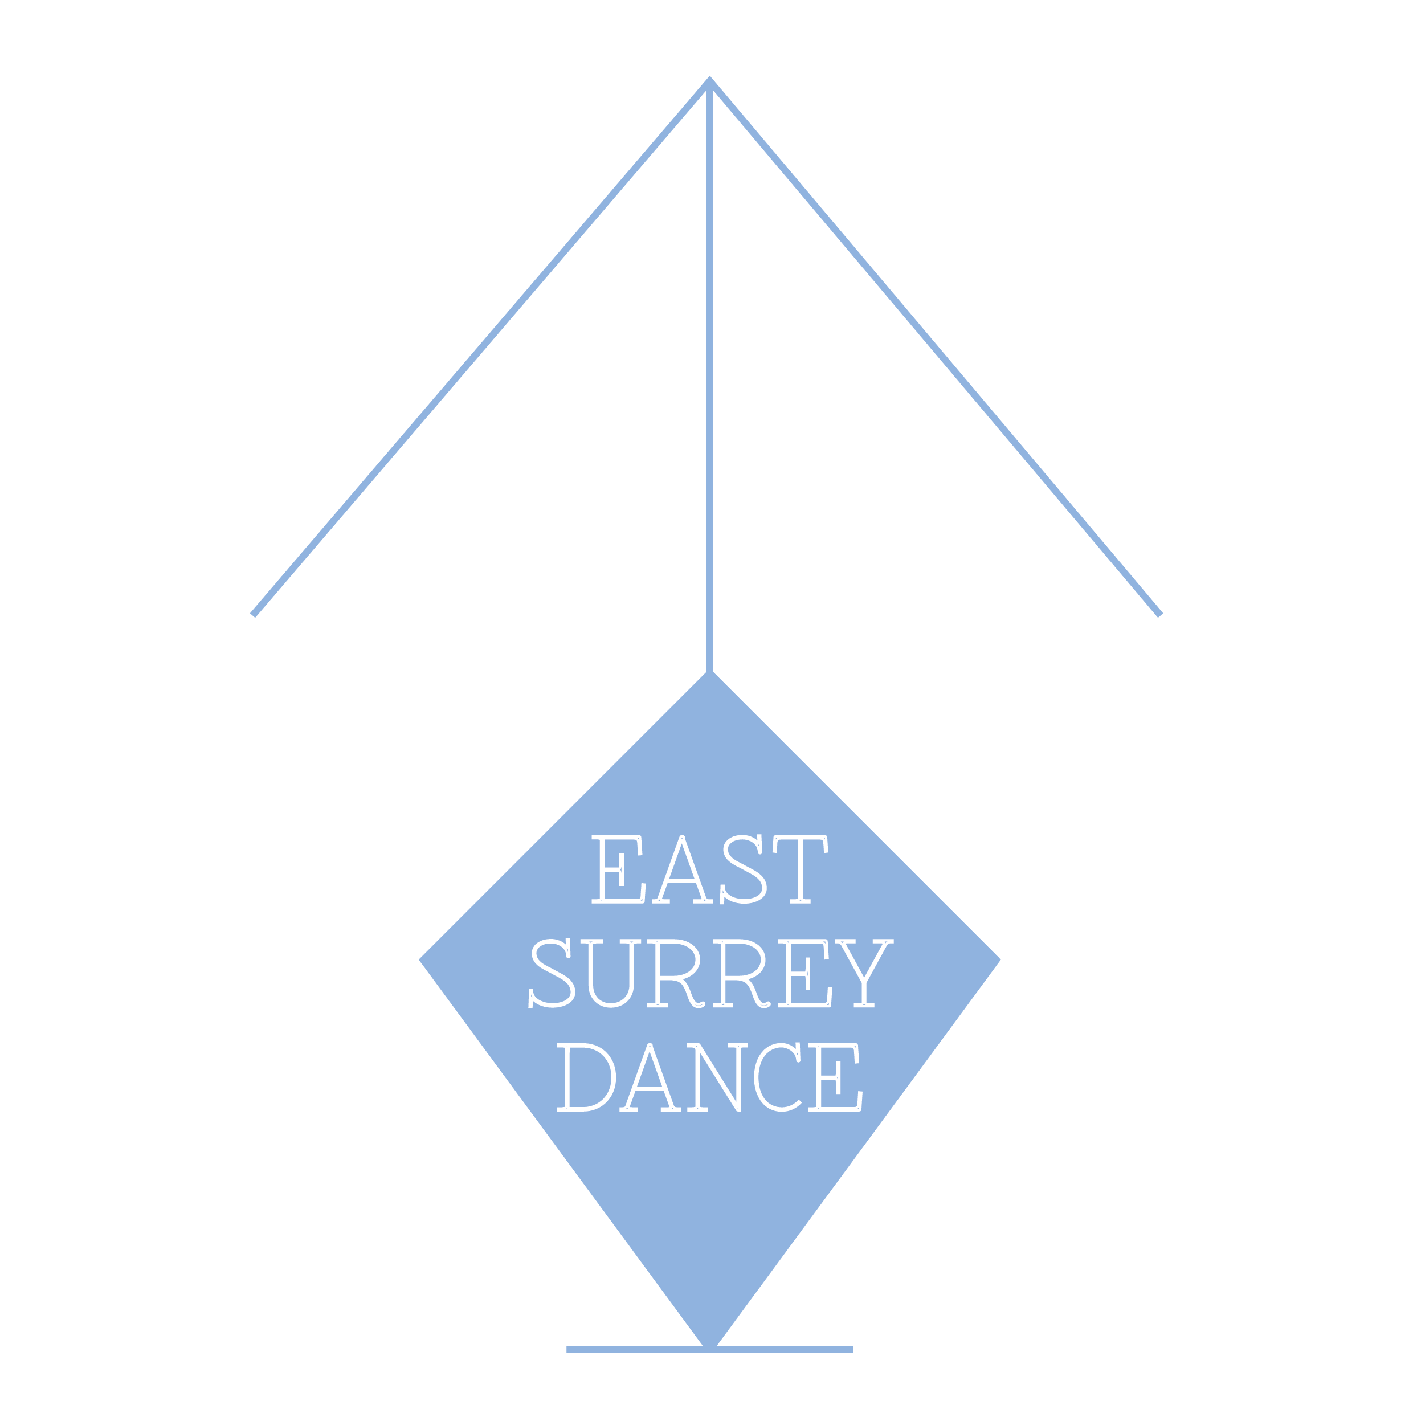

East Surrey Dance Uniform

Students are requested to wear the uniform appropriate to their grade or class (please see the uniform list below). Female students should have their hair neatly tied back and it is preferred that students in Grade 1 Ballet and up should have their hair in a bun.

In the interests of health and safety and safe dance practice, jewellery must not be worn, unless for religious or cultural reasons.

The uniform can be obtained from The Ballet Box (29 High Street, Caterham on the Hill CR3 5UE 01883 342518), Royal Academy of Dance Enterprises Ltd on-line or from our second hand supplies.

Girls | Boys
Swans and Cygnets – Parent and Toddler Group
Suitable and comfortable soft clothing to move in  Bare feet or pink ballet shoes fastened with 12mm matching pink elastic | Suitable and comfortable soft clothing to move in  Bare feet or white ballet shoes fastened with 12mm white elastic
Pre School/Nursery Ballet, RAD Pre-Primary and Primary
Lilac Short-sleeved leotard (Brand: Freed & Style: Chloe)  Lila Georgette wrap over skirt (Brand: Freed & Style: Georgette)  Short pink ballet socks  Pink leather or satin ballet shoes fastened with 12mm matching pink elastic  Lilac crossover cardigan (optional) | White short-sleeved leotard (Brand: Freed & Style: Aaron) or white T-Shirt  Navy Shorts (Brand: Freed)  Short white ballet socks  White ballet shoes fastened with 12mm white elastic
RAD Grades 1-3
Marine Blue sleeveless leotard without ruche and with a matching waist elastic (Brand: Freed & Style: Aimee)  Short pink ballet socks (or pink Ballet tights for Grade 3)  Pink leather or satin ballet shoes fastened with 12mm matching pink elastic  Character skirt - Black (Pastel ribbon colours)  Black Canvas Character Shoe (Low Heel for Grades 1 and 2 and Cuban heel for Grade 3) fastened with pink 12mm elastic (Brand: Katz & Style: Syllabus) | White short-sleeved leotard (Brand: Freed & Style: Aaron) or white T-Shirt  Navy shorts (Brand: Freed)  Short white ballet socks  White ballet shoes fastened with 12mm white elastic  Black Character shoes (Brand: Katz & Style: Oxford)
RAD Grades 4-5
Navy sleeveless leotard with ruche and matching waist elastic (Brand: Freed & Style: Faith)  Pink ballet tights  Pink leather or satin ballet shoes fastened with 12mm matching pink elastic  Character skirt - Black (Pastel ribbon colours)  Black Canvas Character Shoe (Cuban Heel) fastened with pink 12mm elastic (Brand: Katz & Style: Syllabus) | White sleeved or sleeveless leotard (Brand: Freed & Style: Aaron / sleeveless)  Navy stirruped tights (Brand: Freed)  White socks  White ballet shoes fastened with 12mm white elastic  Black Character shoes (Brand: Katz & Style: Oxford)
Modern and Tap (Woldingham)
Regulation hot pink leotard  Black footless tights  White short socks for tap  Black leather low heeled tap shoes  Bare feet for modern | School Dance T-shirt  Black shorts  White short socks for tap  Black leather low heeled tap shoes  Bare feet for modern

